Celticsam Foundation
  - Proudly Presents 2023 NCAC and Celticsam Scholarship
Application Deadline  May 20, 2023  Send Application to:  juliettefenner@gmail.com  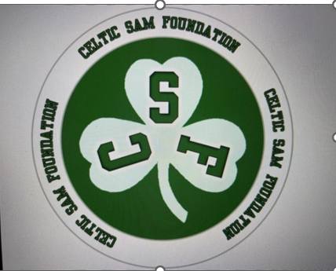 | 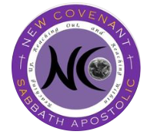

Questions:

Juliette Fenner

juliettefenner@gmail.com
470-257-4200

Celticsam Foundation
  - Application Criteria

Submit Application to celticsamfoundation@gmail.com by May 20, 2023.
To be eligible to apply for an academic Celticsamfoundation scholarship, the following criteria must be met:
- Must be an active member of New Covenant Sabbath Apostolic Church.
- Must have volunteered and played an active role in 3 church activities to include 1 Celticsam activity. Must also have 1 outside community service activity.
- Must submit two references from someone who is not a family member (i.e school reference, community reference).
- Must submit a 600 Word Essay on why you should be selected for the scholarship. Include what contributions you plan to make that will have an impact on the future youth, the world, and how you plan to give back to the community.
- Must be planning to attend a trade school, college or university in 2023. Please indicate the trade school, college, or university that you plan to attend. Are you receiving an additional scholarship from another source?

Winner will be announced at the Senior Awards Service. Congratulations on your achievements throughout your high school career. We look forward to you to being a major impact on the world!

Wishing you the best,
New Covenant Apostolic Church
Celticsam Foundation

CelticsamFoundation
  - Additional Information

Name:
Birthday:
Favorite Color(s):
Snacks:
Theatre: Yes No Theatre: AMC Fandango Regal Cinemark
Soda:
Candles: Yes No Scents:
Coffee/Tea
Baked Goods/Sweet Treat:
Lotions: Yes No
Flower/Plant:
Hobbies:
Restaurants:
Favorite Place(s):
Characters (Disney, Marvel, Star Wars, etc):
Anything else you would like to share?
Sports: Yes No Which ones?
Favorite Teams:
Future Plans/Goals:

